**CYBER FORENSIC**

NAME: MONIKA BHAGWAN DESAI

ROLL NO: 531

MSC-CS(SEM 3)

**Mini Project: Write a program to take backup of MySQL database.**

We use Python Language to take backup of MySQL database

Code:

TableData.py file ->

This code create ‘mydatabase.db’ which contains Agent table with all details

import sqlite3

from sqlite3 import Error

def sql_connection():

try:

conn = sqlite3.connect('mydatabase.db')

return conn

except Error:

print(Error)

def sql_table(conn):

cursorObj = conn.cursor()

# Create the table

cursorObj.execute("CREATE TABLE salesman(salesman_id n(5), name char(30), city char(35), commission decimal(7,2));")

# Insert records

cursorObj.executescript("""

INSERT INTO salesman VALUES(5001,'James Hoog', 'New York', 0.15);

INSERT INTO salesman VALUES(5002,'Nail Knite', 'Paris', 0.25);

INSERT INTO salesman VALUES(5003,'Pit Alex', 'London', 0.15);

INSERT INTO salesman VALUES(5004,'Mc Lyon', 'Paris', 0.35);

INSERT INTO salesman VALUES(5005,'Paul Adam', 'Rome', 0.45);

""")

conn.commit()

cursorObj.execute("SELECT * FROM salesman")

rows = cursorObj.fetchall()

print("Agent details:")

for row in rows:

print(row)

sqllite_conn = sql_connection()

sql_table(sqllite_conn)

if (sqllite_conn):

sqllite_conn.close()

print("\nThe SQLite connection is closed.")

Output:

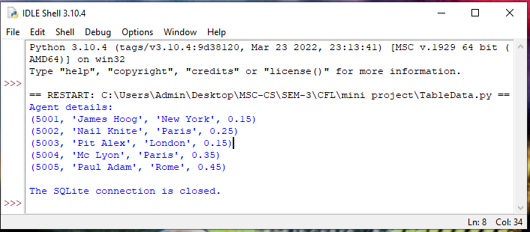



BackupData.py ->

This code give total database backup with table details.

import sqlite3

import io

conn = sqlite3.connect('mydatabase.db')

c = conn.cursor()

def backupdb():

b_conn=sqlite3.connect('backupdatabase.db')

conn.backup(b_conn)

b_conn.close()

backupdb()

c.close()

print(' Backup performed successfully!')

print(' Data Saved as backupdatabase.db')

conn.close()

Output:

